10.2 Editors - Shader Editor - Tool Shelf
Tool Shelf 2
Select Tools Group 2
Tweak 2
Select Box 2
Tool Settings 2
Mode 2
Set a new selection 2
Extend existing selection 2
Subtract existing selection 2
Select Circle 2
Tool Settings 3
Mode 3
Set a new selection 3
Extend existing selection 3
Subtract existing selection 3
Radius 3
Select Lasso 3
Tool Settings 3
Mode 3
Set a new selection 3
Extend existing selection 3
Subtract existing selection 3
Annotate Tools group 3
Annotate 4
Annotate Line 4
Annotate Polygon 4
Tool Settings 4
Color 4
Note 4
Annotations list 4
Edit Box 4
Fake User 4
Add Annotation 4
Unlink Annotation 5
Thickness 5
Frame Locked/Unlocked 5
Delete Active Frame 5
Thickness 5
Annotate Eraser 5
Tool Settings 5
Radius 5
Links Cut 5

Tool Shelf

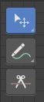

Select Tools Group
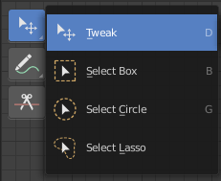
Tools with a triangle down right are a group of tools. Click and hold to reveal the content. Then choose the tool that you need.

Tweak
Allows you to select or tweak single elements by clicking at it.

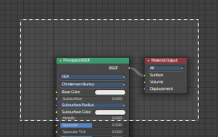
Select Box
Draws a box to select several elements at once. Click at the start point, then drag.

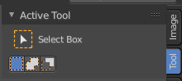
Tool Settings

Mode
The available selection modes. The mode titles are pretty self explaining. So i won't go into detail here.

Set a new selection

Extend existing selection

Subtract existing selection

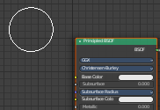
Select Circle
Draws a box to select several elements at once. Click at the start point, then drag.

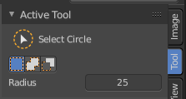
Tool Settings

Mode
The available selection modes. The mode titles are pretty self explaining. So i won't go into detail here.

Set a new selection

Extend existing selection

Subtract existing selection

Radius
The brush radius.

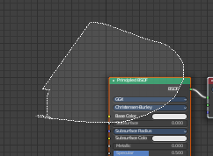
Select Lasso
Draws a box to select several elements at once. Click at the start point, then drag.

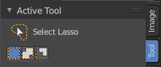
Tool Settings

Mode
The available selection modes. The mode titles are pretty self explaining. So i won't go into detail here.

Set a new selection

Extend existing selection

Subtract existing selection

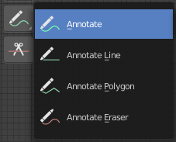
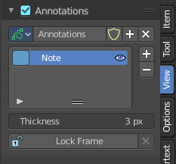
Annotate Tools group
The annotation tool is available in multiple editors. With this tool you can write notes at the screen. The annotate tools is the little brother of the grease pencil objects.
Further settings for annotate can be found in the sidebar. Here you can also remove an annotation when you don't longer need it. And here you can also adjust the size of the stroke.
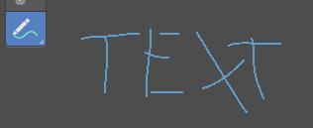

Annotate
Draw free-hand strokes in the main window.

Annotate Line
Click and drag to create a line.

Annotate Polygon
Click multiple times to create multiple connected lines. The current polygon is finished when Esc or RMB is pressed.

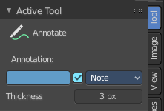
Tool Settings
The tool settings for Annotate, Annotate Line and Annotate Polygon are the same. Different from the 3D view, there is no placement option for the 3d cursor.

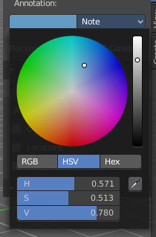
Color
Clicking at the left color field reveals a color picker where you can define the color for the annotation stroke.

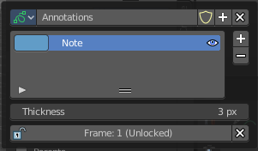
Note
Clicking at the Note dropdown box reveals a panel with further settings. It's the same content than in the annotations in the View tab.

Annotations list

Here you can add, remove and rename new annotations.

Edit Box
The name of the current annotation. You can rename the annotation to your needs here.

Fake User
Assign a fake user to this annotation. Fake users is a odd concept to keep data in the scene even if it has no user somewhere. The fake user is then a dummy user so that the object is not deleted when saving the scene.

Add Annotation
Add a new annotation.

Unlink Annotation
Delete the annotation.

Thickness
The thickness of the annotation stroke.

Frame Locked/Unlocked
Lock frame displayed by current layer. This toggles whether the active layer is the only one that can be edited.

Delete Active Frame
Deletes the active frame from the active grease pencil layer.

Thickness
The thickness of the annotation stroke.

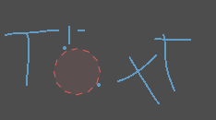
Annotate Eraser
Click and drag to remove annotate lines.

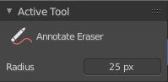
Tool Settings

Radius
The radius of the eraser pencil.

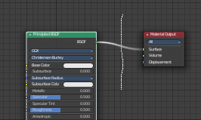
Links Cut
This tools allows you to cut connections.

